There is a huge amount of space between paragraphs and sections:

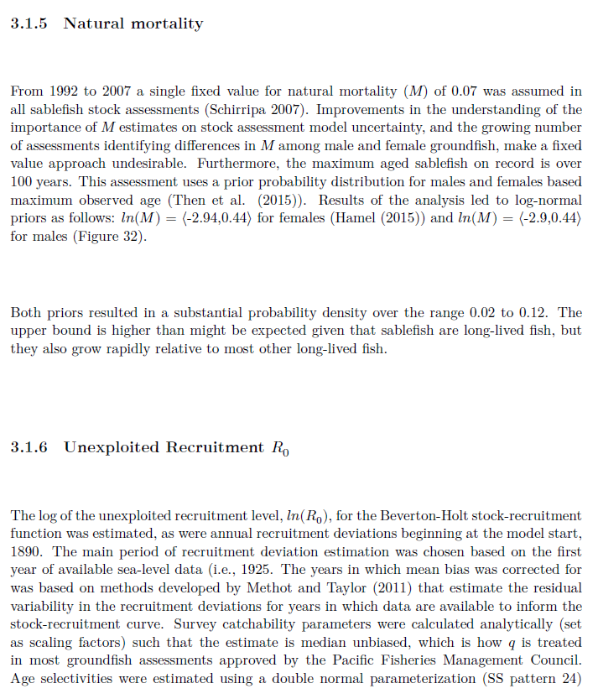

So, this is saying that around 2013-14, there was as much survey biomass south of 36as the entire coast north of there?

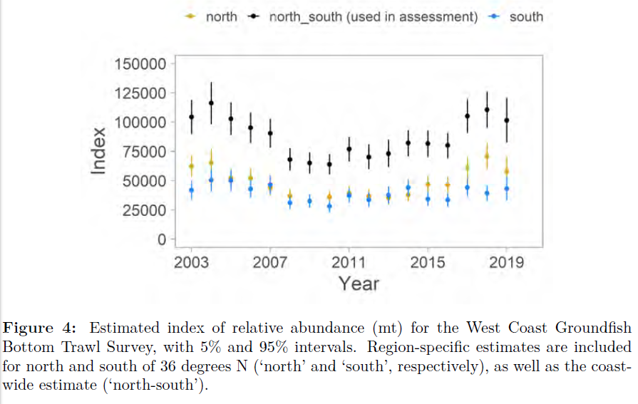

Putting 17 of these on a single page pretty much removes any opportunity to discern anything.

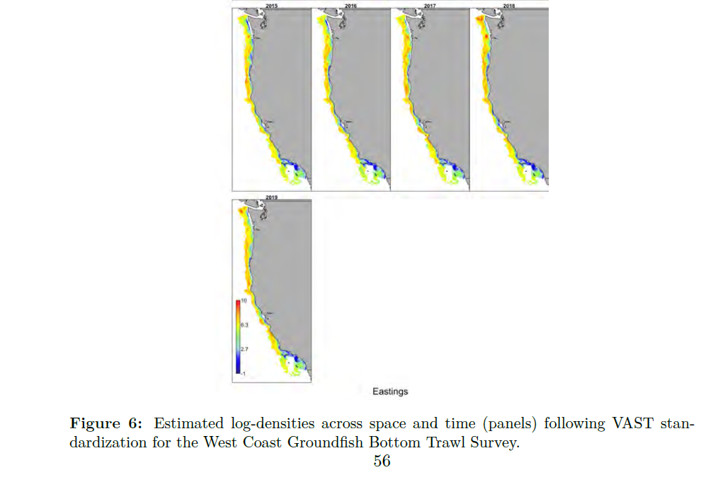

Likewise, putting 17 of these on a single page pretty much removes any opportunity to discern anything.

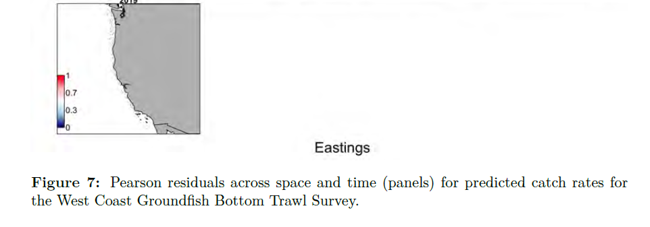

LiThe label above this lower panel should probably be ‘by survey’ not ‘by fleet’, to reduce confusion.

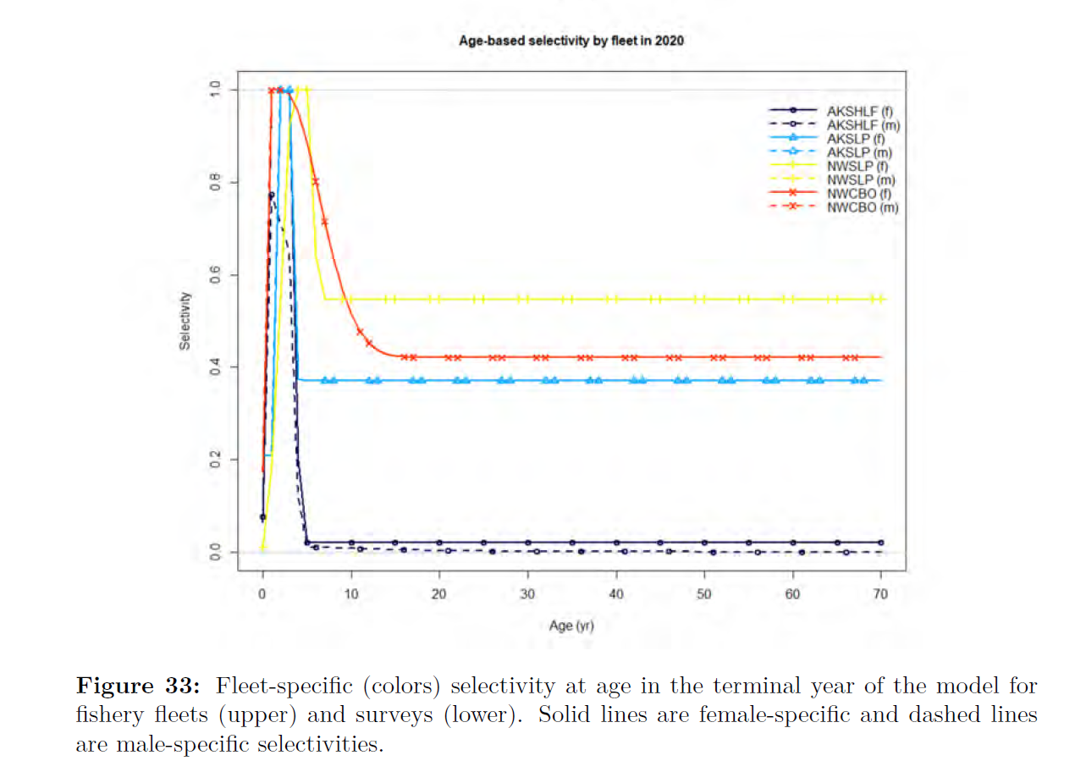

Is this really better than just saying Figure 44 (cont.), or Figure 44a, 44b…

Figure 45: The continuation of Figure 44 but for more recent years.

Figure 46: The continuation of Figure 44 but for more recent years.

Figure 47: The continuation of Figure 44 but for more recent years.

Technically, if numbered this way, wouldn’t 46 be a continuation of 45?

The word ‘but’ also seems out of place.

~~It would be nice to have a table with the SSH timeseries being used in the model data.~~

What is shown here as 2019 Benchmark does not appear to be the same as what is reported as the SL_Index in the 2019 document… I THINK DOCUMENT IS OUT OF DATE; THIS DEFINITELY USES SS VALUES FROM 2019.

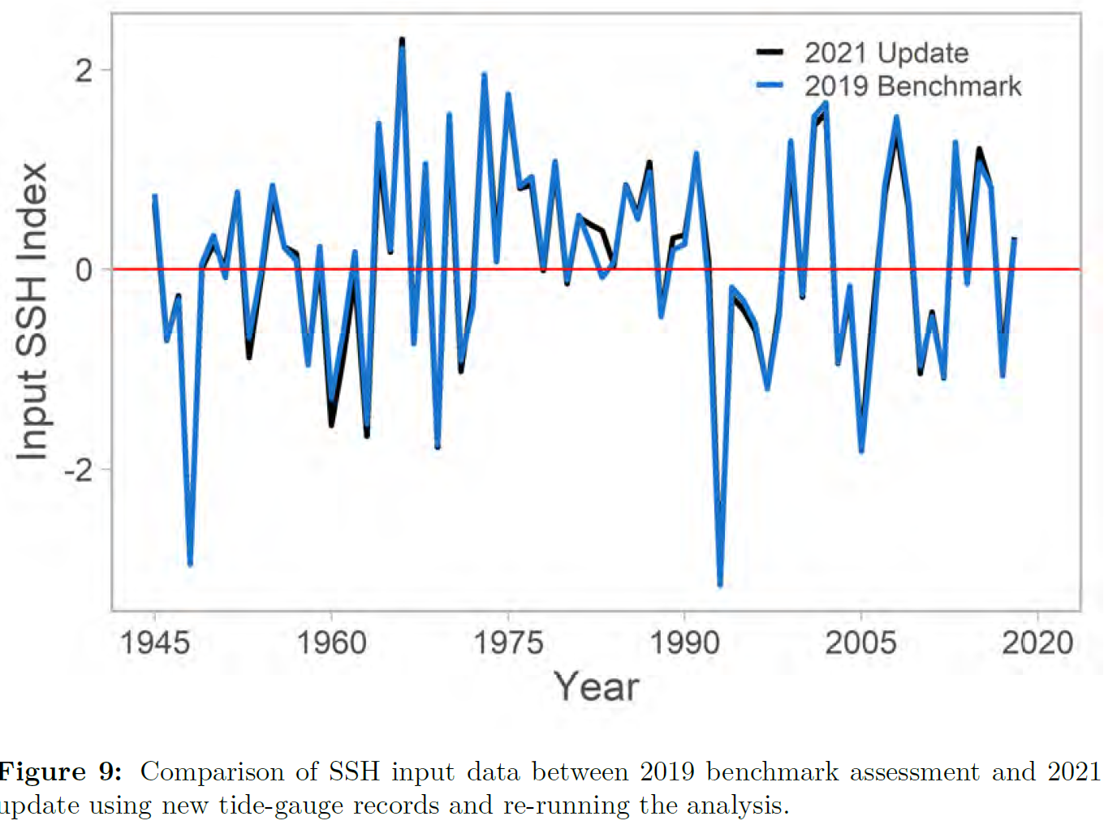

Also, I didn’t see any discussion about whether there was any impact of these data on the estimation of the most recent recruit classes, where there is typically less data to inform strength. (and especially this year, where recent survey data is reduced)

Additionally, i was a bit surprised that the confidence bounds on the 2019 survey index value didn’t seem to increase much. Do you think that is mainly a function of the fact that we encounter sablefish in such a high % of hauls?

I am always worried when we start seeing weird recruitment spikes occurring around the time that the bias adjustment starts going into effect.

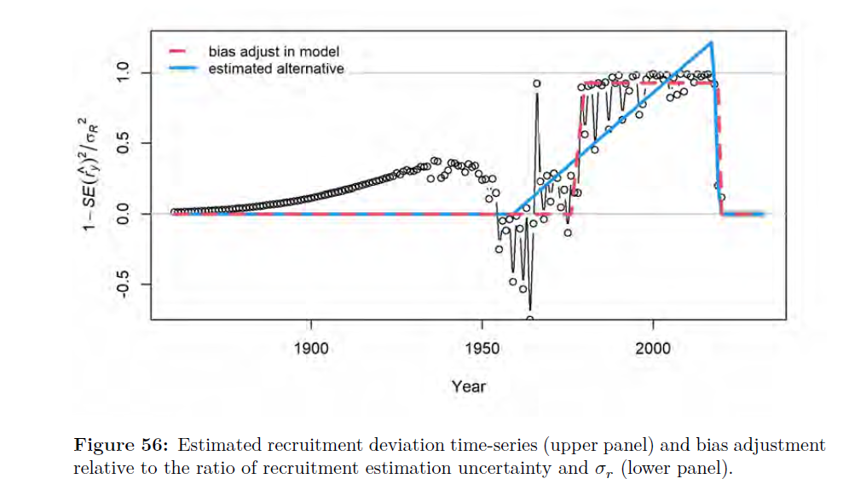

I can’t remember if it is still that way, but the bocaccio assessment used to have that one HUGE recruitment around that time that stood out like the one in this model.